# PROCEDURE

1. Go to figma.com.

2. Sign in with your enrollment number.

3. On Figma home page click on design file.

4. Give title to your file.

EX: File is “PROTOTYPE”

Page 1: HOME PAGE.

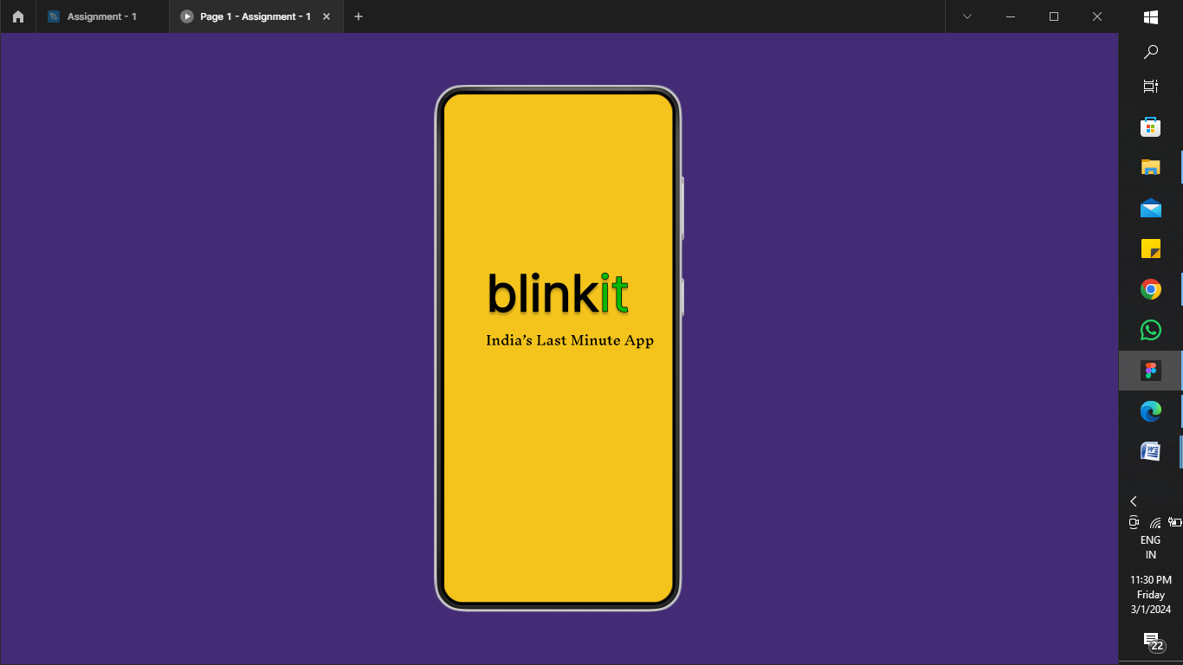

Page 2: Introduction - 1.

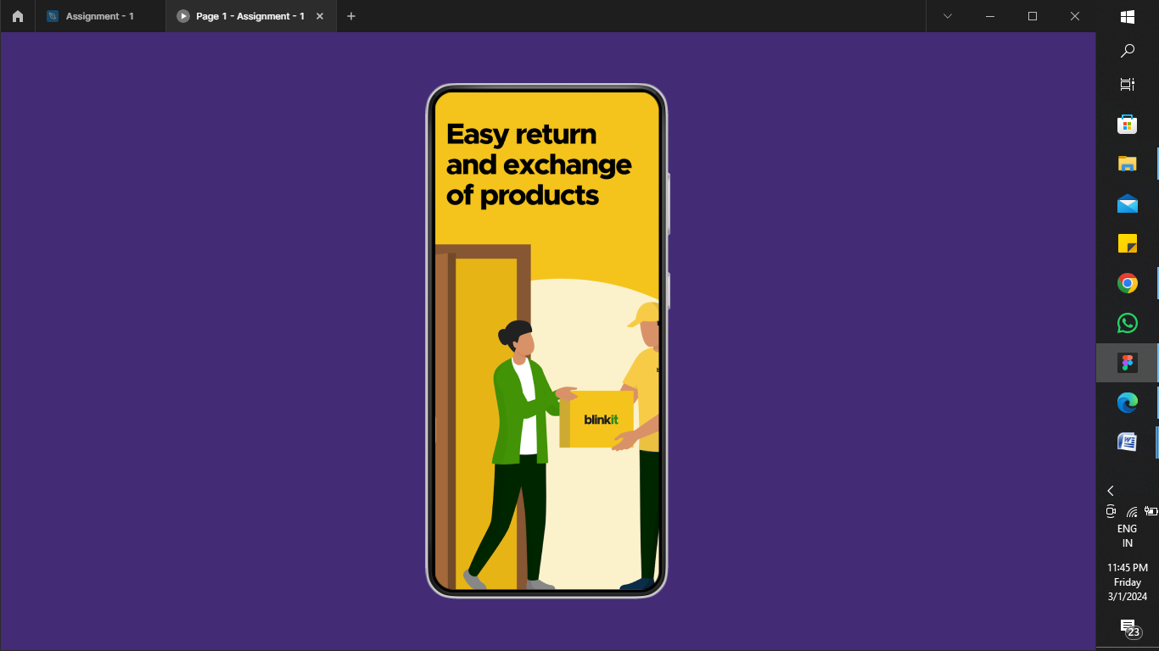

Page 3: Introduction - 2.

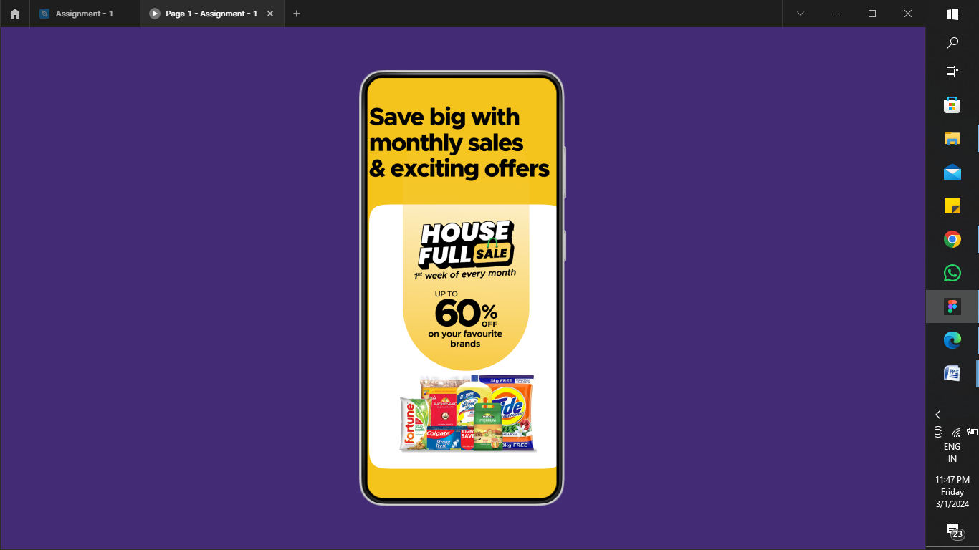

Page 4: Sign up.

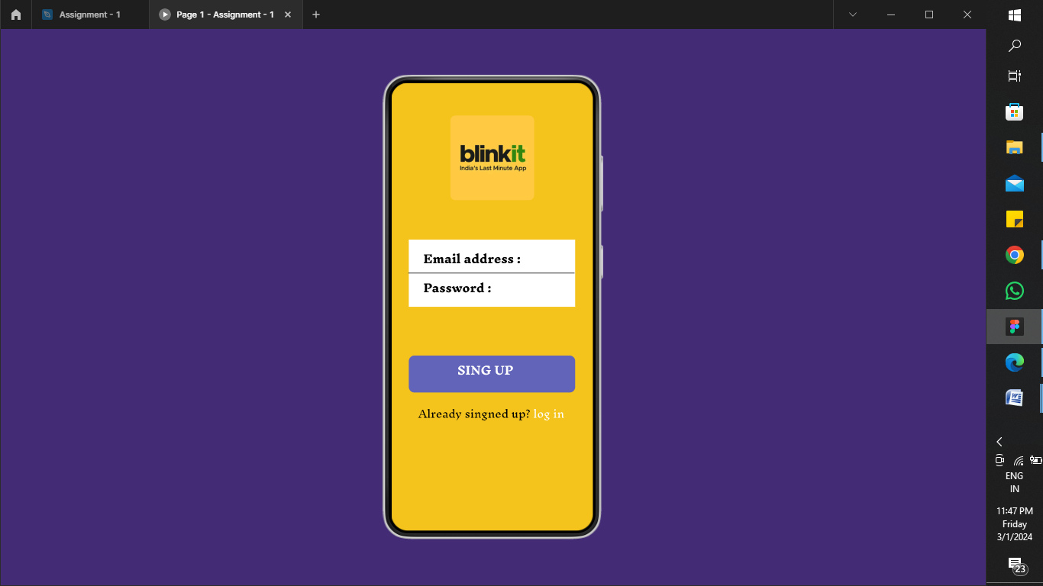

Page 5: Discount.

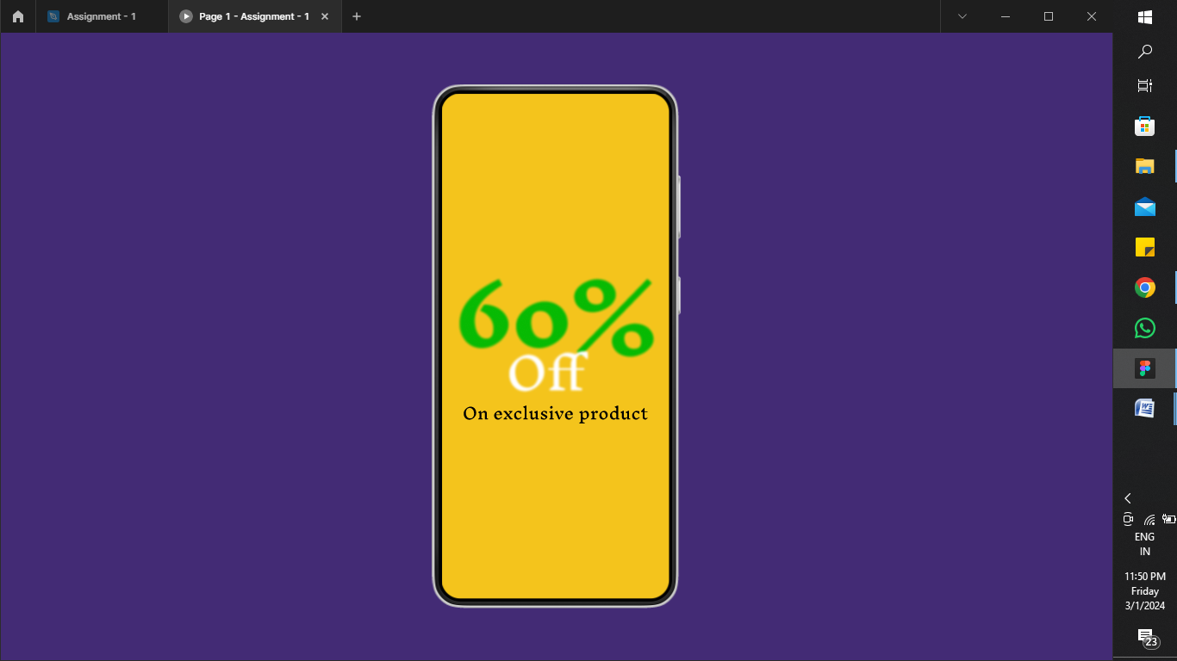

Page 6: Product list – 1.

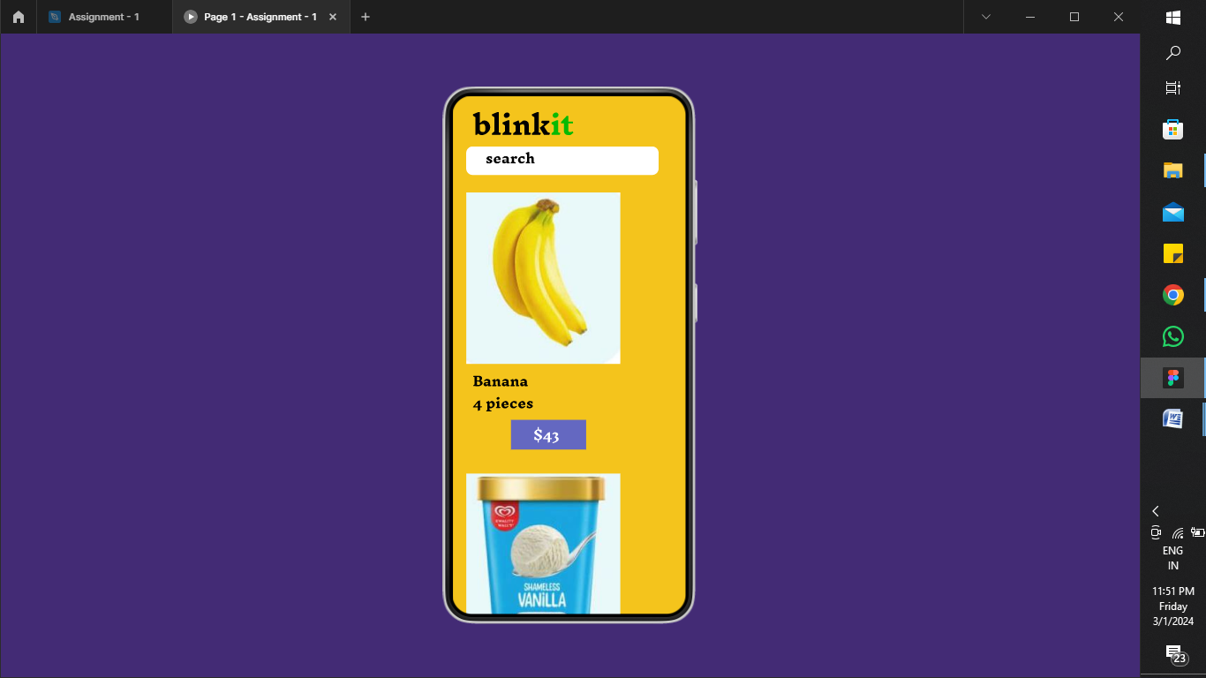

Page 7: Product list – 2.

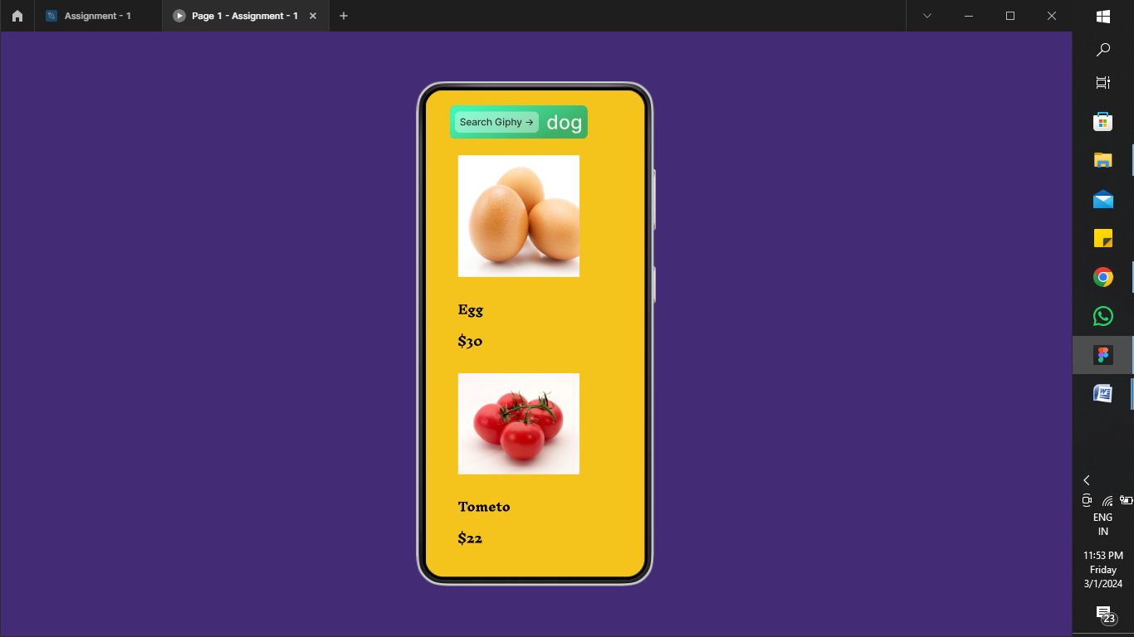

Page 8: Product list – 3.

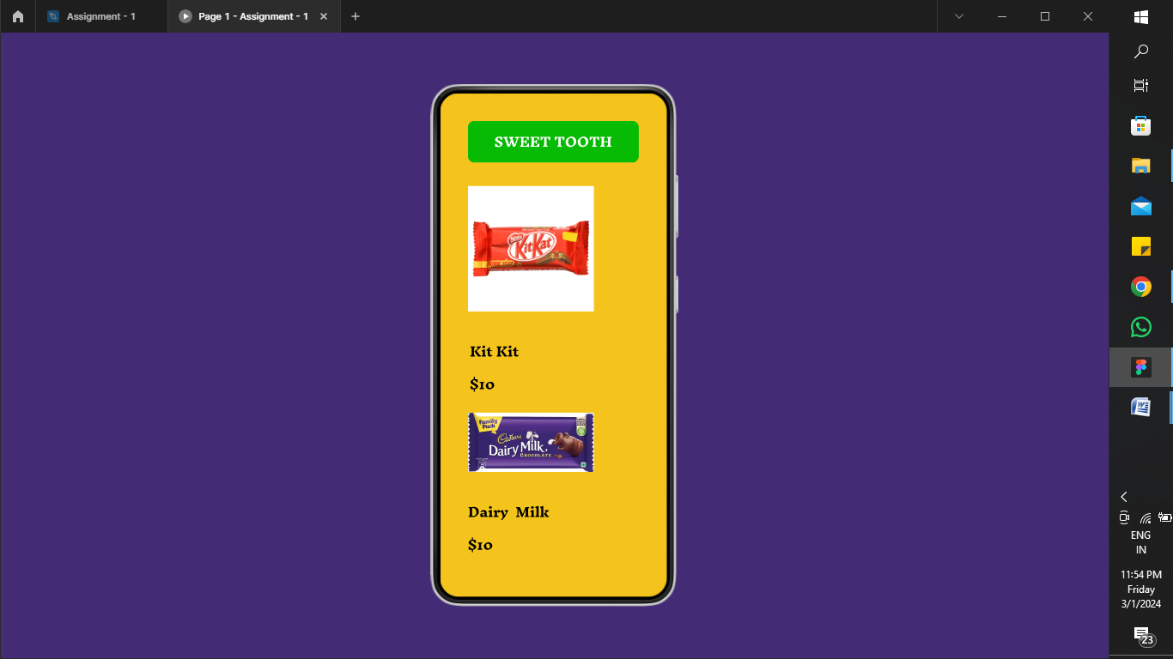

Page 9: Product add card.

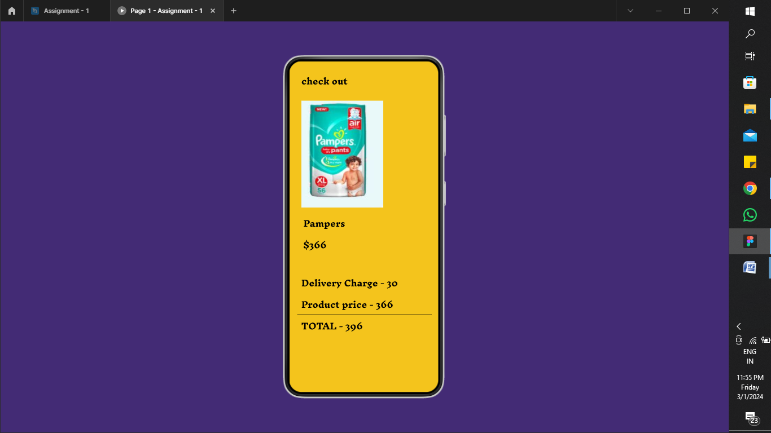

Page 10: Payment.

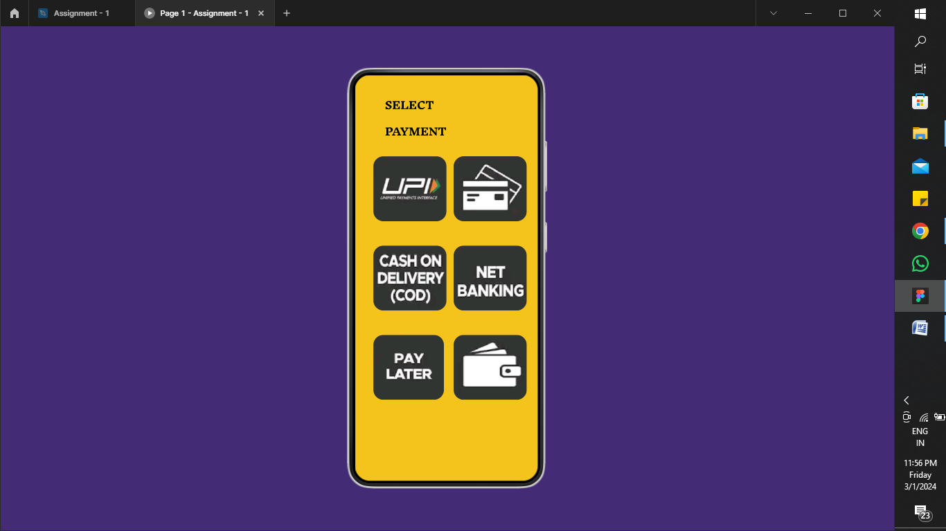

Page 11: Order tracking .

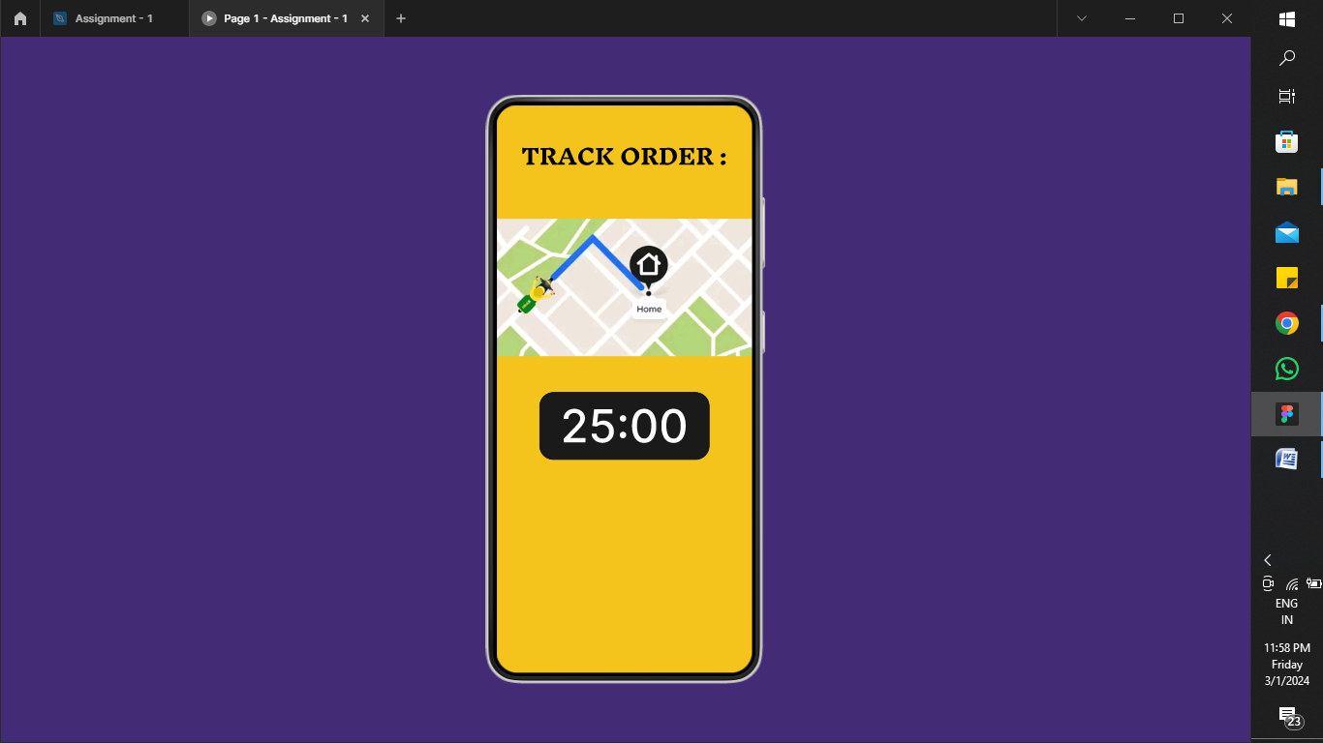

Page 12: Query .

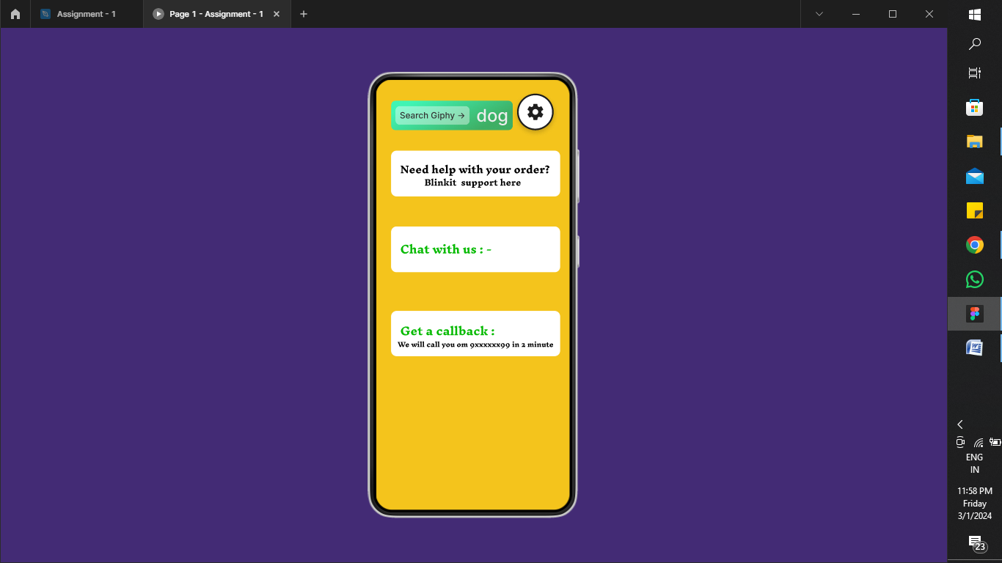

Page 13: Rating .

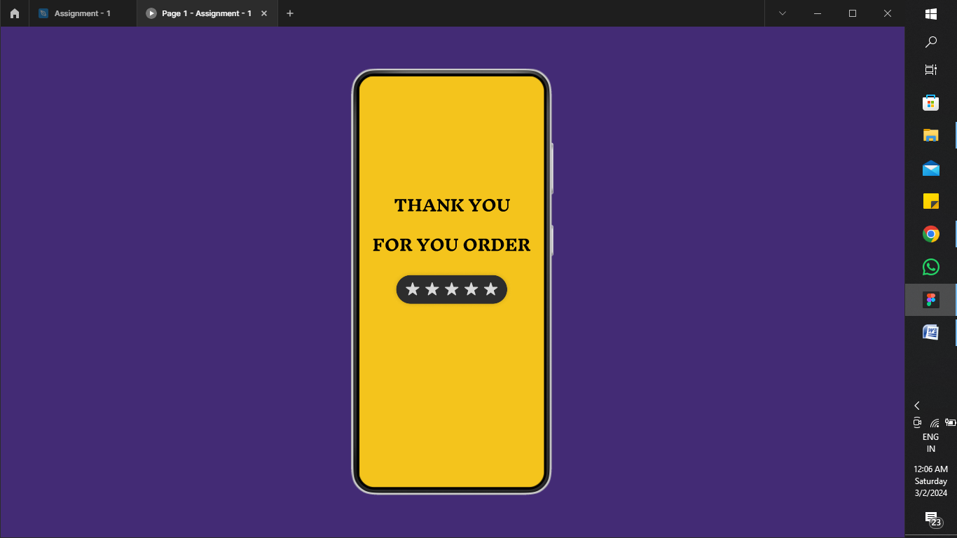

Page 14: App experience.

